**Description:**

**Task: Deploy Application in Monolothic and Microservices Architecture**

**---- For Monolithic: 1 EC2 Instance, deploy Wordpress and MySQL on the same Instance.**

**---- For Microservices: 2 EC2 Instances, 1 for Wordpress and 1 for MySQL**

**---- Configure the necessary security group for the instances.**

**---- EC2 Instance type: t2. micro, AMI: ubuntu**

**Task 1:**

**For Monolithic: 1 EC2 Instance, deploy Wordpress and MySQL on the same Instance.**

1. **Created 1 Instance:**

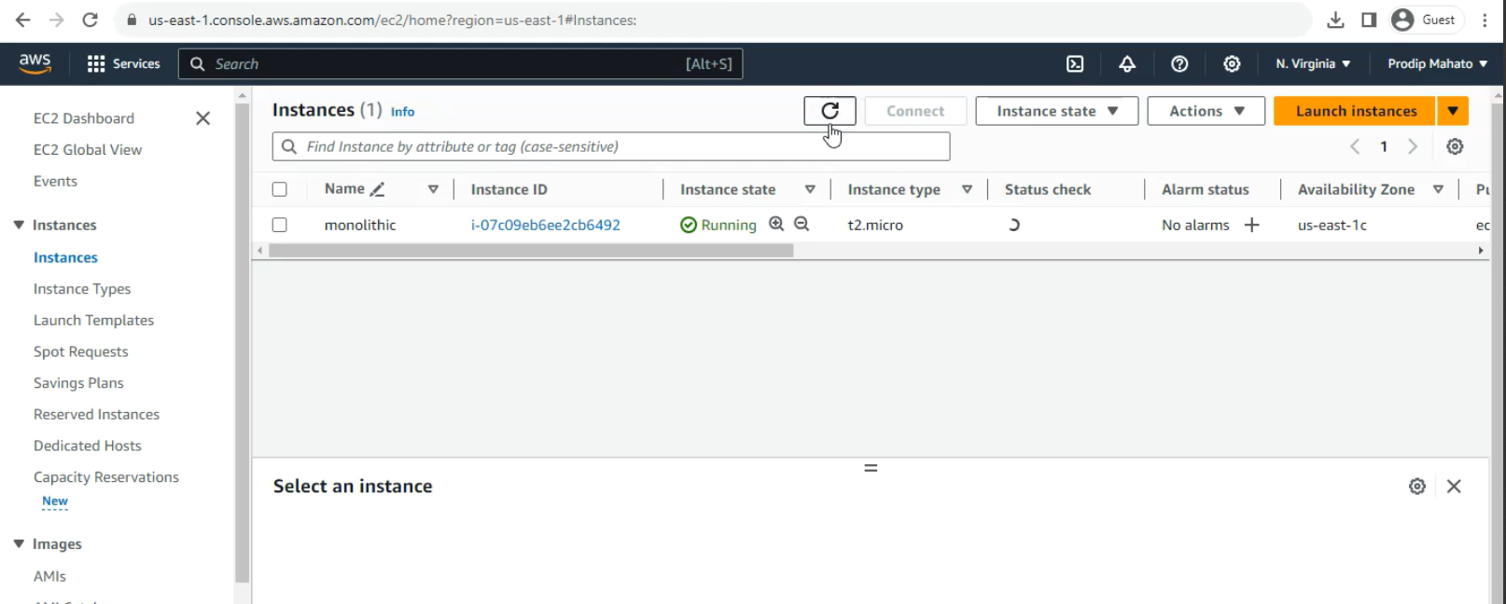

1. **Updated the server: sudo apt-get update**

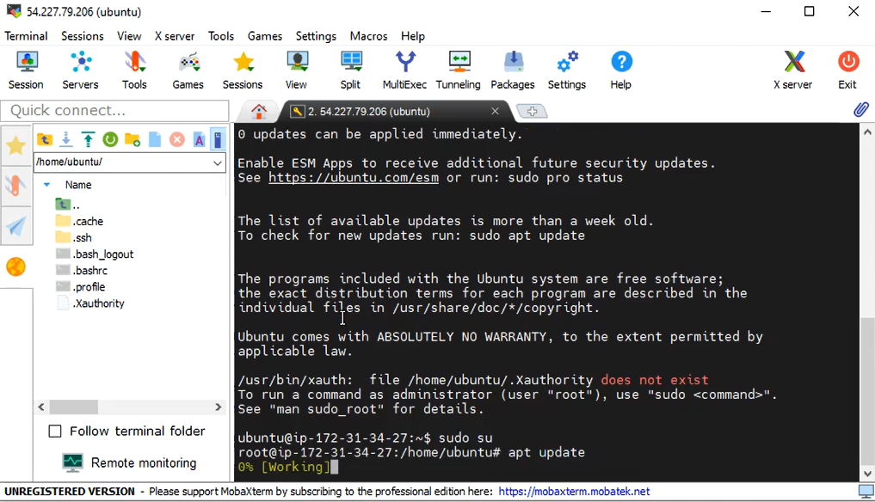

1. **Installing apache webserver on the instance: sudo apt install apache2**

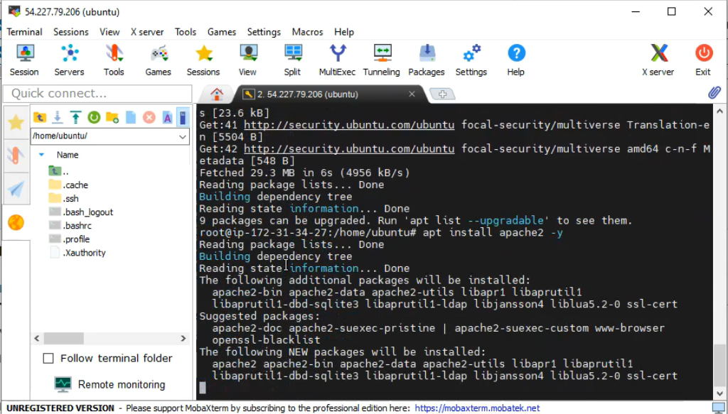

1. **Install php runtime and php mysql connector: sudo apt install php libapache2-mod-php php-mysql**

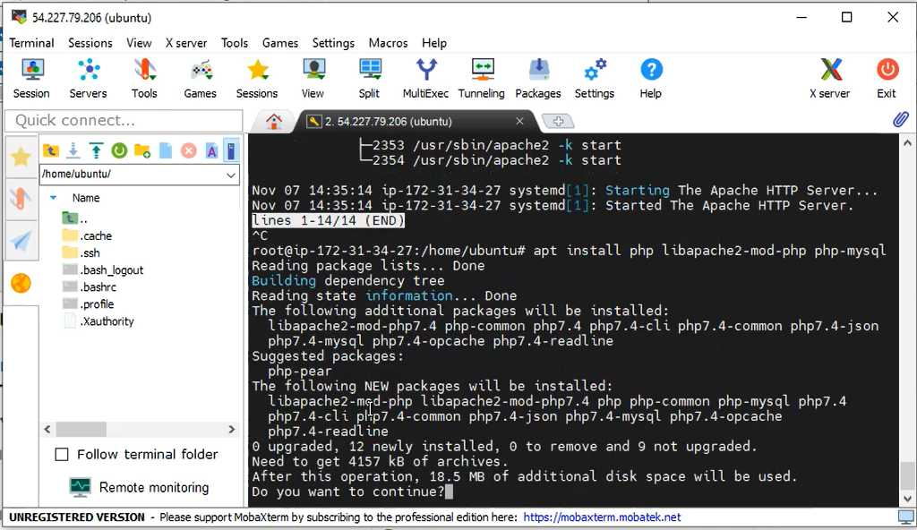

1. **Install mysql-server: sudo apt install mysql-server**

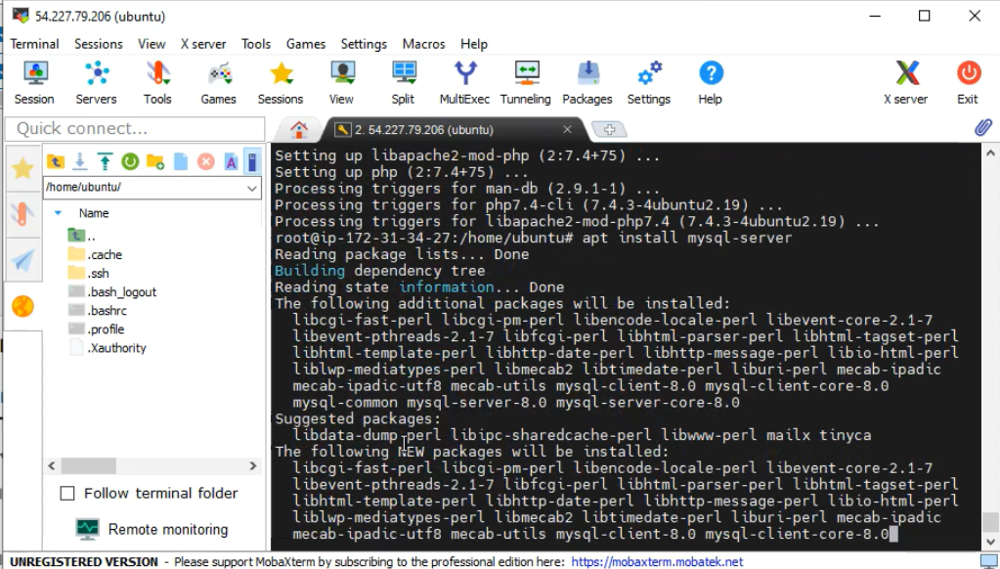

1. **Login to MySQL server: sudo mysql -u root**

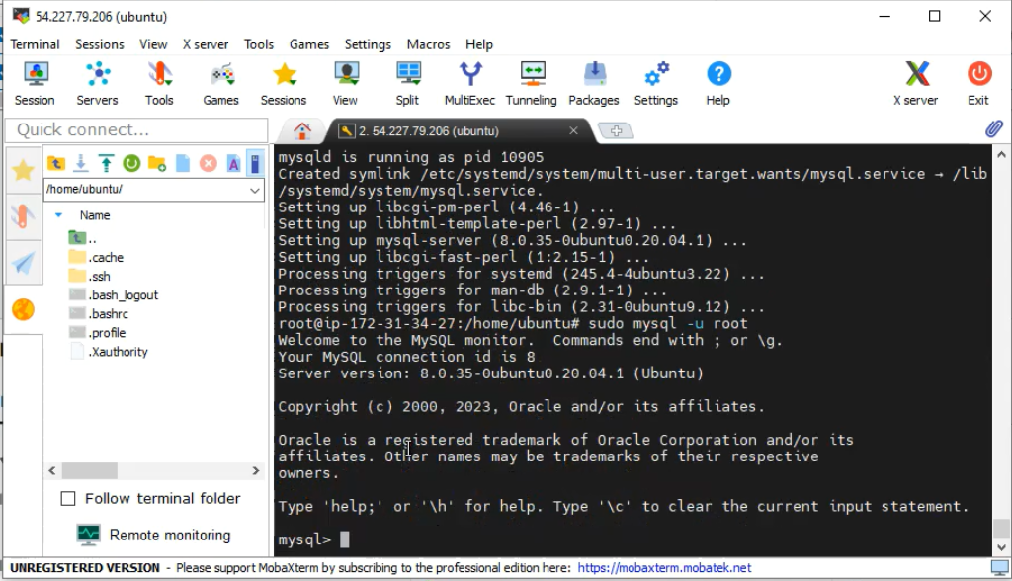

1. **Change authentication plugin to mysql_native_password: ALTER USER ‘root’@’localhost’ IDENTIFIED WITH mysql_native_password by Testpassword@123’;**

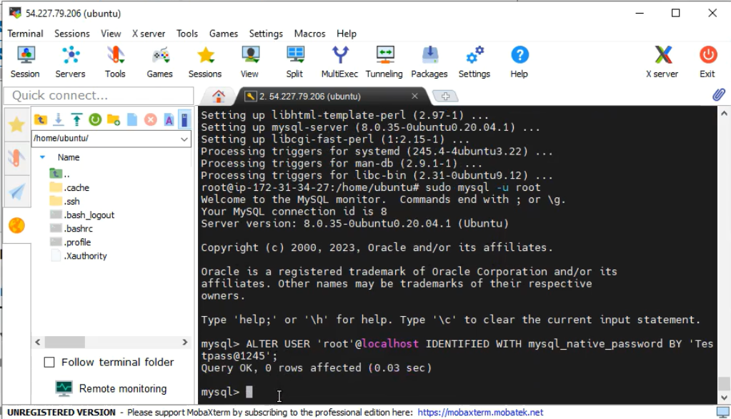

1. **Create a new database user for Wordpress: CREATE USER ‘wp_user’@’localhost’ IDENTIFIED BY ‘Testpassword@123;**

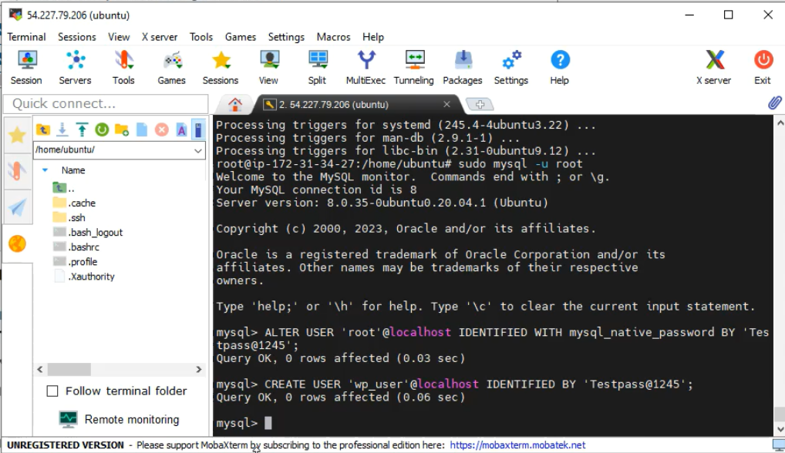

1. **Create a database for Wordpress: CREATE DATABASE WP;**

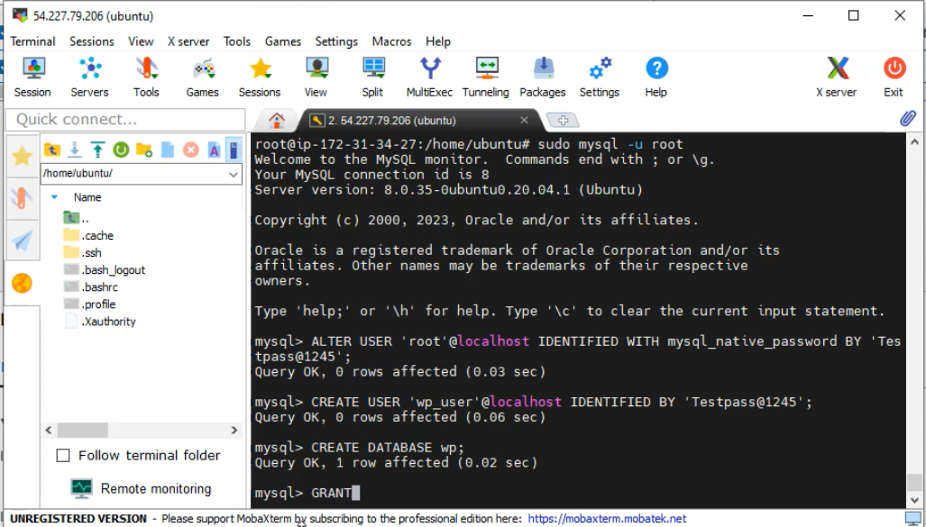

1. **Grant all priviledges on the database WP to the newly created user: GRANT ALL PRIVILEGES ON WP.* TO 'wp_user'@'localhost';**

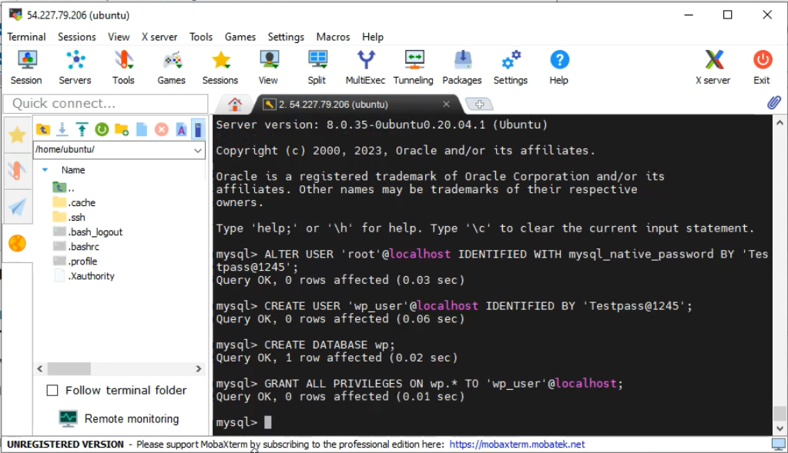

1. **Download Wordpress: cd /var/www/html**

**Wget** [**https://wordpress.org/latest.tar.gz**](https://wordpress.org/latest.tar.gz)

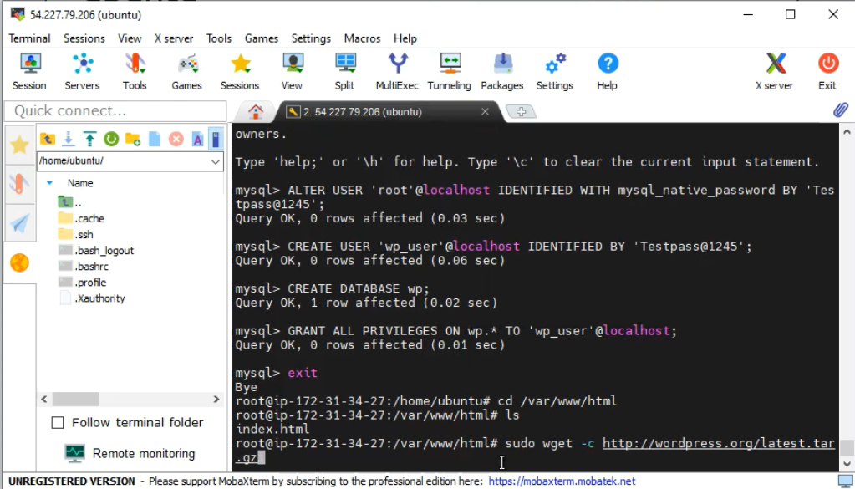

1. **Unzip: tar -xvf latest.tar.gz**

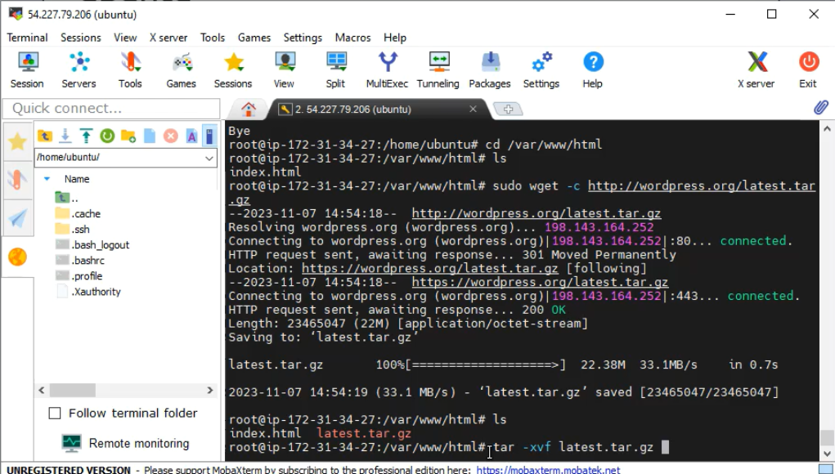

1. **Commands to create config file:**

* Cd /var/www/html
* Cd wordpress
* Nano wp-config.php

1. **Wordpress website:**

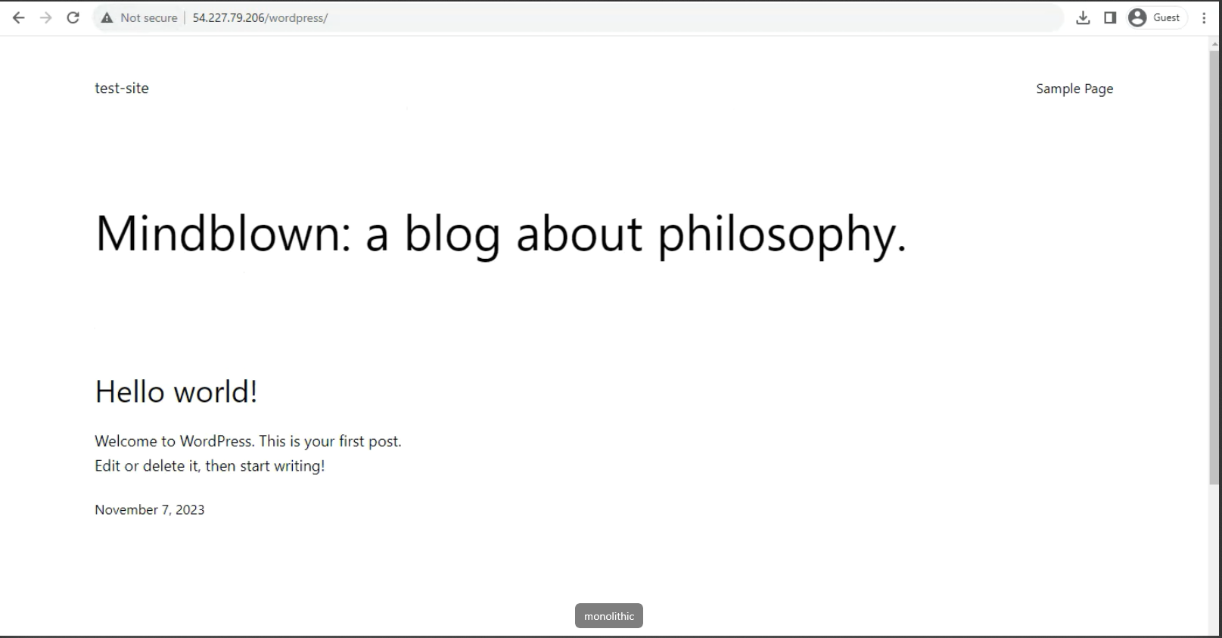

**Task 2:**

**For Microservices: 2 EC2 Instances, 1 for Wordpress and 1 for MySQL:**

1. **Created 2 EC2 Instances- 1 for Wordpress and 1 for MySQL:**

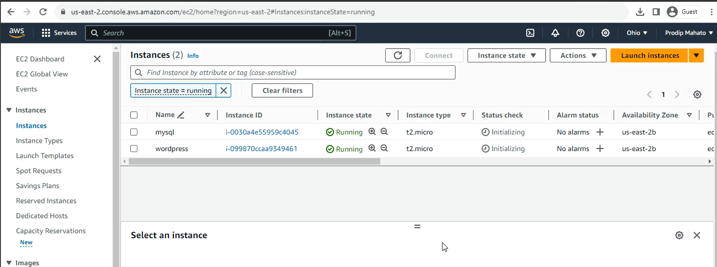

1. **Configured the security groups of the instances:**

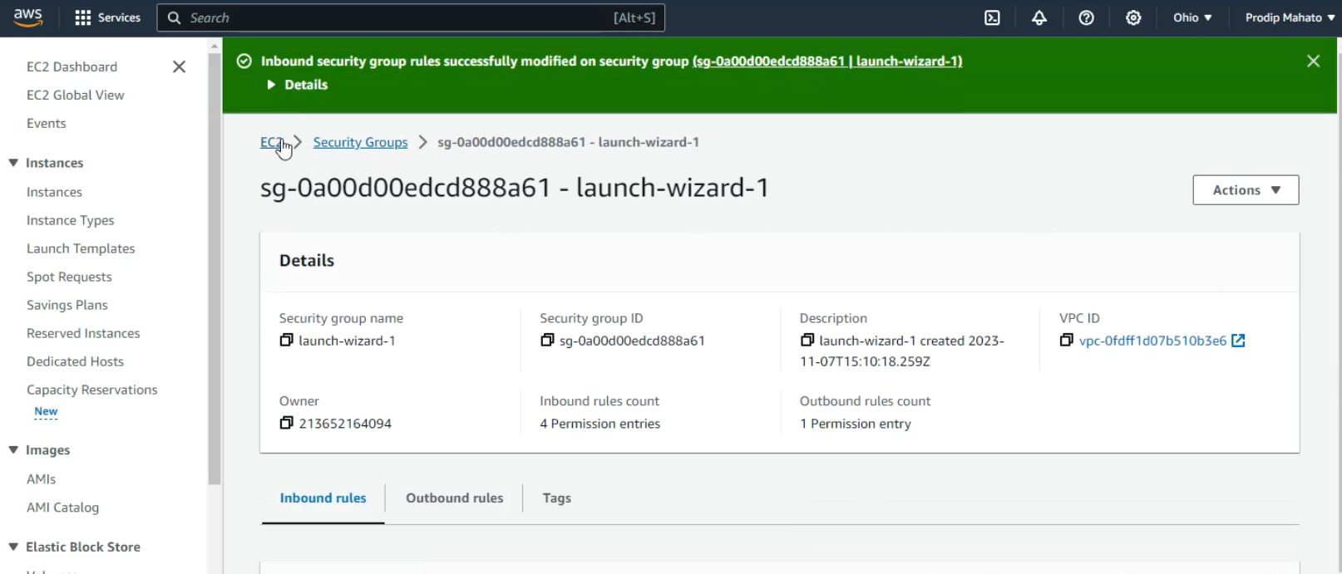

1. **Connected to the MySQL server and updated:**

**Command: sudo apt update**

1. **Install php runtime and php mysql connector: sudo apt install php libapache2-mod-php php-mysql**

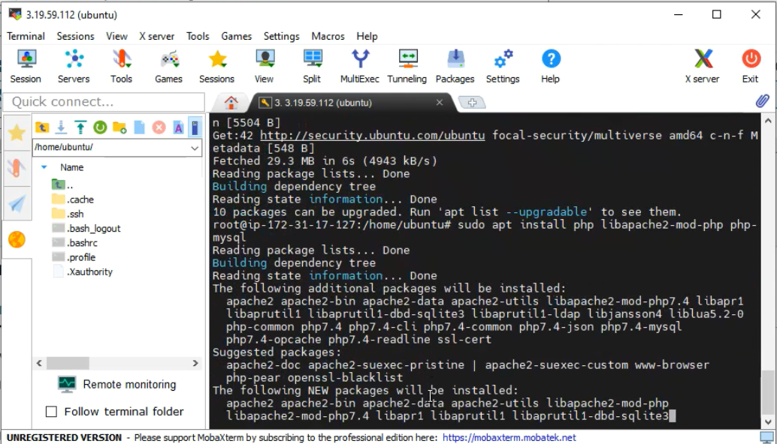

1. **Install mysql-server: sudo apt install mysql-server**

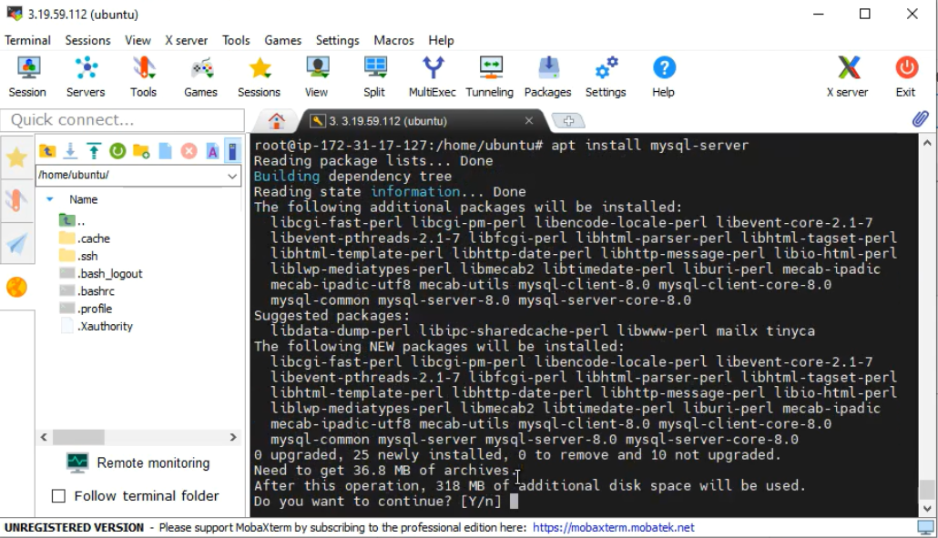

1. **Login to MySQL server: sudo mysql -u root**

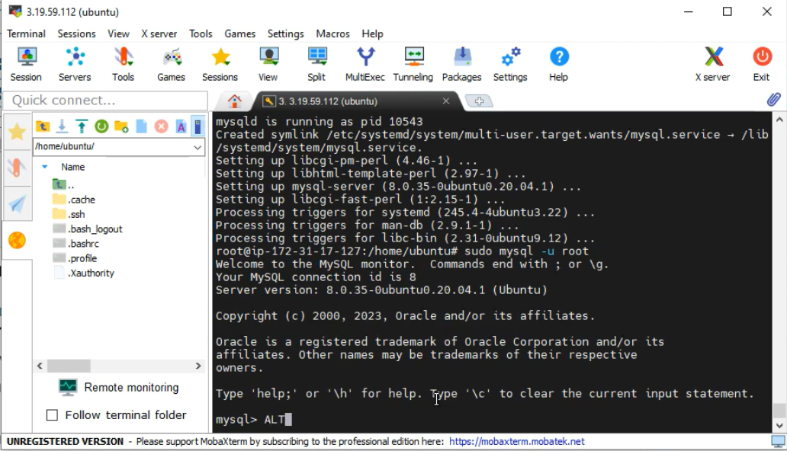

1. **Change authentication plugin to mysql_native_password: ALTER USER ‘root’@’localhost’ IDENTIFIED WITH mysql_native_password by ‘Testpassword@123’;**

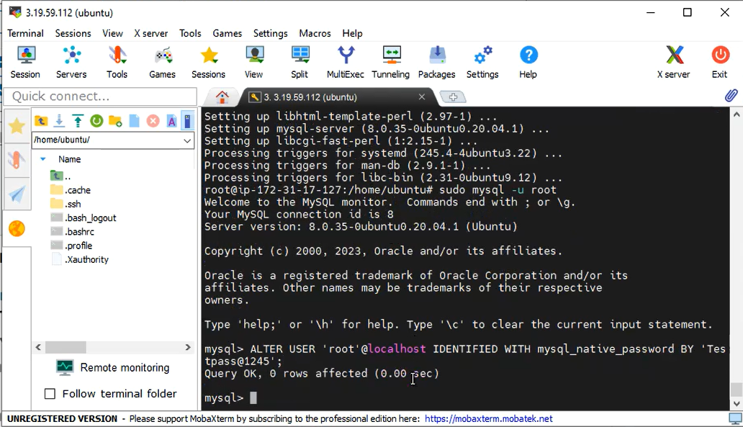

1. **Create a new database user for Wordpress: CREATE USER ‘wp_user’@’localhost’ IDENTIFIED BY ‘Testpassword@123;**

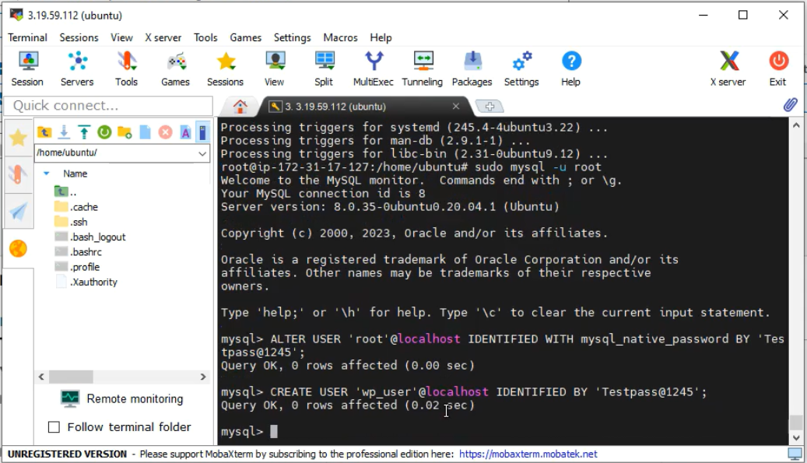

1. **Create a database for Wordpress: CREATE DATABASE wp;**

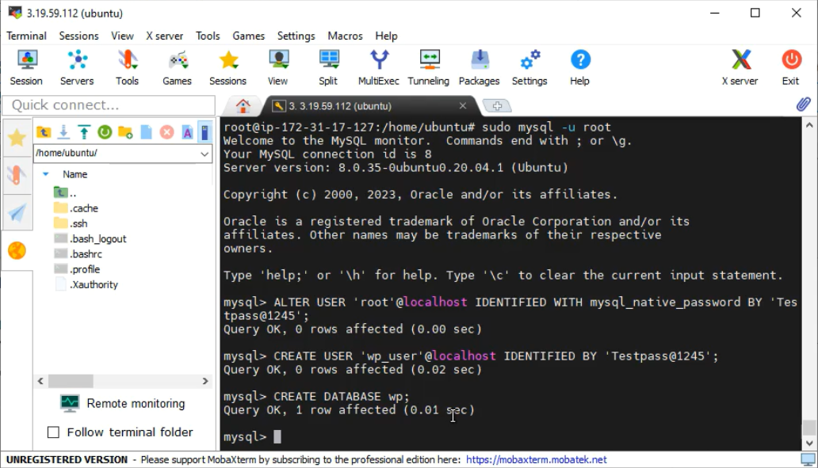

1. **Grant all priviledges on the database wp to the newly created user: GRANT ALL PRIVILEGES ON wp.* TO 'wp_user'@'localhost';**

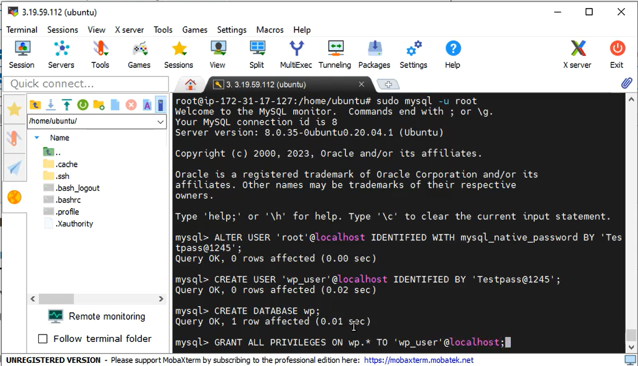

1. **Connected to the Wordpress server and updated:**

**Command: sudo apt update**

1. **Installing apache webserver on the instance: sudo apt install apache2 -y**

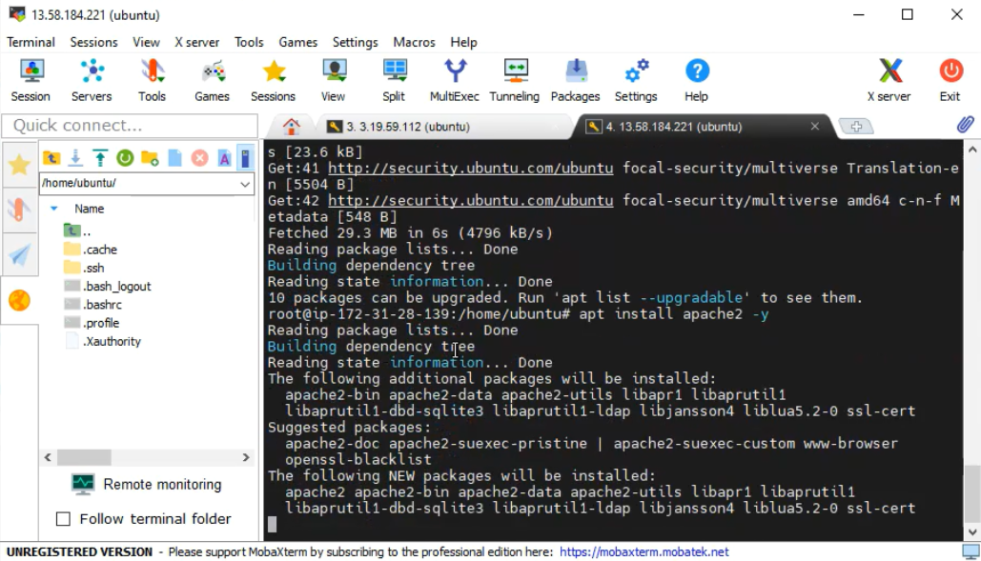

1. **Install php runtime and php mysql connector: sudo apt install php libapache2-mod-php php-mysql**

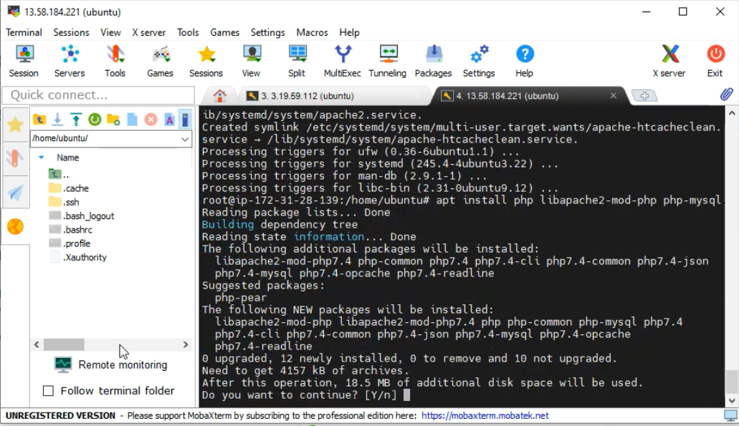

1. **Download Wordpress:**

**wget** [**https://wordpress.org/latest.tar.gz**](https://wordpress.org/latest.tar.gz)

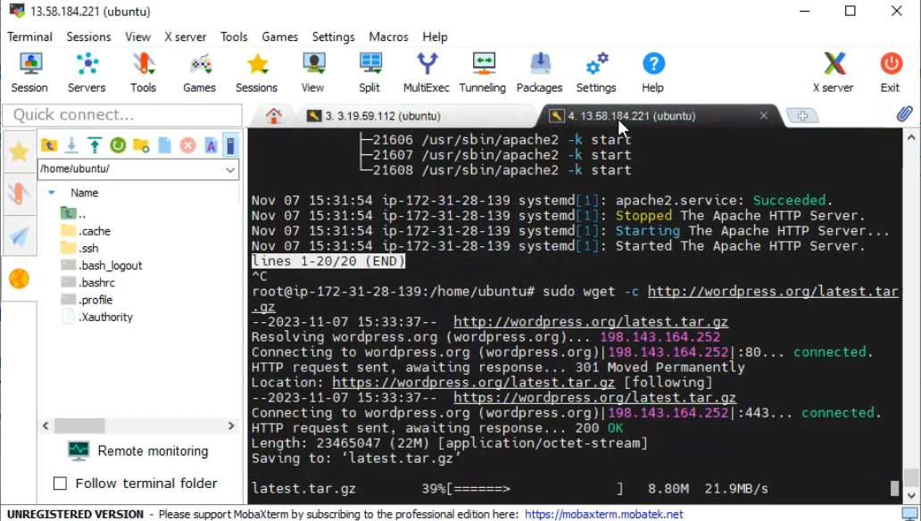

1. **Move Wordpress folder to apache document root: mv wordpress/ /var/www/html**

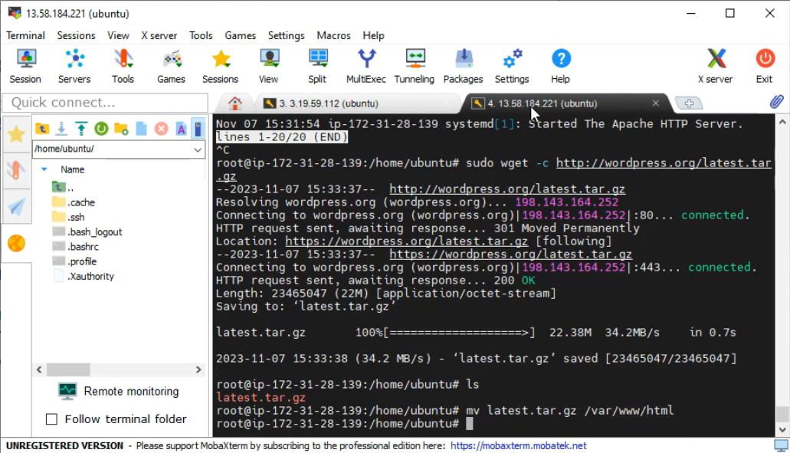

1. **Unzip: tar -xvf latest.tar.gz**

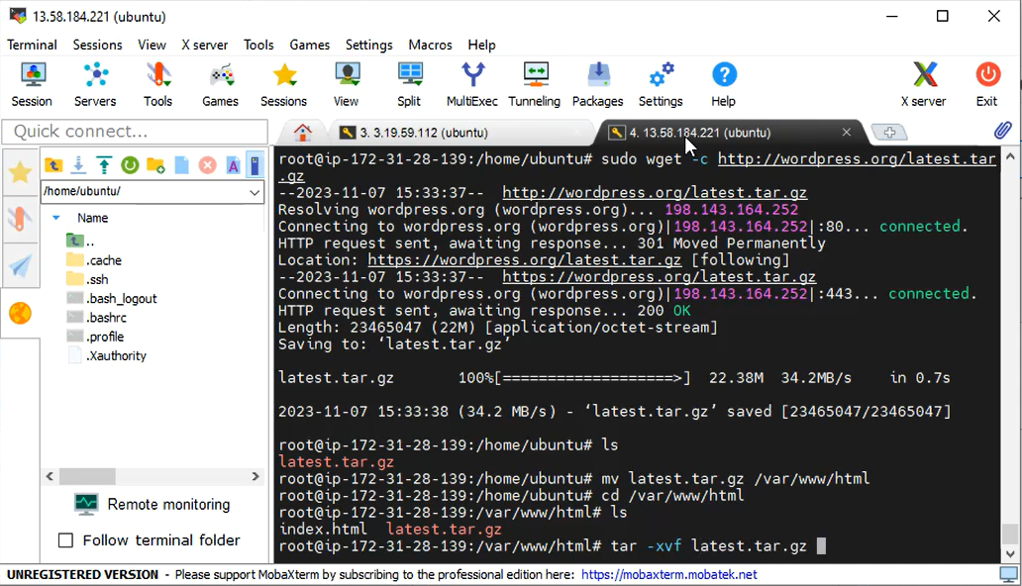

1. **Commands to create config file:**

* Cd /var/www/html
* Cd wordpress
* Nano wp-config.php

1. **Wordpress website:**

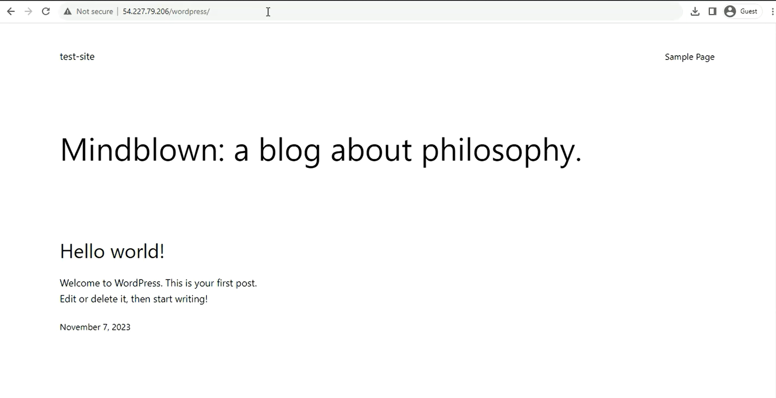

**Thank you!!**